
BeOne’s 4Q/FY2025 Earnings; Ph 1/2 study of sonro in AML ongoing; KATA6A/Bi and next-gen pan-mutant menin inhibitor for AML to enter clinic in 2026 and 2027

Company: BeOne  Drug: Sonrotoclax (BG-11417; BCL2i); BG-75202 (KAT6A/Bi), undisclosed drug (pan-mutant menin inhibitor) | Date: Feb 26, 2026  Source(s): Presentation, Webcast, Press Release, Clinical Trial Portfolio
What happened:
- BeOne published its 4Q/FY2025 earnings results and first-time announced two new drug candidates targeting KAT6A/Bi and a pan-mutant menin inhibitor expected to enter clinic in 2026 and 1H 2027 respectively for AML (LoTs remain undisclosed)
- Ph 1/2 study continues to be enrolling; no guidance provided on Ph 3 initiation plans for sonrotoclax in 1L unfit AML

Impact (CI PoV): MEDIUM
- Despite no formal updates of sonrotoclax in 1L unfit AML, emerging signals suggest BeOne is possibly actively shaping its next move, where the awaited data from the ongoing Ph 1/2 sonrotoclax study may shape the development path
- Beyond sonrotoclax, the addition of a KAT6A/Bi and a next-generation pan-mutant menin inhibitor underscores a deliberate multi-asset AML strategy, potentially enabling in-house combinations and resistance-focused positioning that could intensify competitive pressure on Ven, particularly if execution mirrors BeOne’s rapid CLL trajectory

Approval timelines:
 | US | EU
1L unfit AML  (Planned registrational study;  sonrotoclax + Aza) | 4Q 2029  (sNDA + 6 mo, if approved first in CLL; no changes to timelines) | NA  (Plans are not clear for EU. Therefore, it is premature to include it in the timelines; no changes to timelines)

Why it matters (CI Insights in blue italics):
Sonrotoclax
- The Ph 1/2 (1L unfit AML, R/R AML, sonrotoclax + Aza, N=260) study is included in the clinical trial appendix as ‘enrolling’ (reiterated)
- Despite the absence of formal updates on sonrotoclax in AML, the inclusion of AML in the corporate presentation under the ‘early hematology’ portfolio signals active strategic planning is underway
  - CI primary intel from EHA 2025 indicated BeOne is likely refining dosing and scheduling (potentially pursuing a shorter duration than Ven to mitigate myelosuppression) before formally advancing its next development phase
  - Additionally, CI primary intel from EHA 2025 indicates potential interest in pursuing R/R Ven-naïve AML patients as a key unmet need and strategic differentiation opportunity vs Ven
Other Assets
- BeOne mentioned that beyond sonrotoclax in AML, a focused portfolio to address unmet needs includes “first-in-indication” KAT6A/Bi targeting drug, backed by “strong translational data”, and a next generation pan-mutant menin inhibitor is “designed to overcome all known resistance mutations” (new guidance)
- Despite limited pre-clinical data available and lack of clinical details, BeOne’s confirmation that these assets will enter the clinic in 2026 and 2027 signals clear intent to expand in AML beyond its BCL-2 inhibitor franchise, possibly including in-house combinations with sonrotoclax as backbone
  - While development remains early and definitive timelines or potential impact on Ven cannot yet be assessed, CI assumes BeOne can replicate its rapid execution seen in other indications, like in CLL, where CELESTIAL-TN-CLL study enrolled ~700 patients in 20+ countries in just 14 months and the company filed in the US within 2 months from data cut-off. If similar operational intensity is applied in AML, BeOne could emerge as meaningful competitor faster than anticipated

Tell me more:
Financial Highlights
- The projected revenue for FY2026 is $6.2B - $6.4 B
 | Net Revenue
4Q 2025 | $1.476 B
4Q 2024 | $1.118 B
YoY change | +32%
3Q 2025 | $1.395 B
QoQ Change | +5.8%
FY 2025 | $5.282 B
FY 2024 | $3.78 B
YoY Change | +40%

Relevant Slides
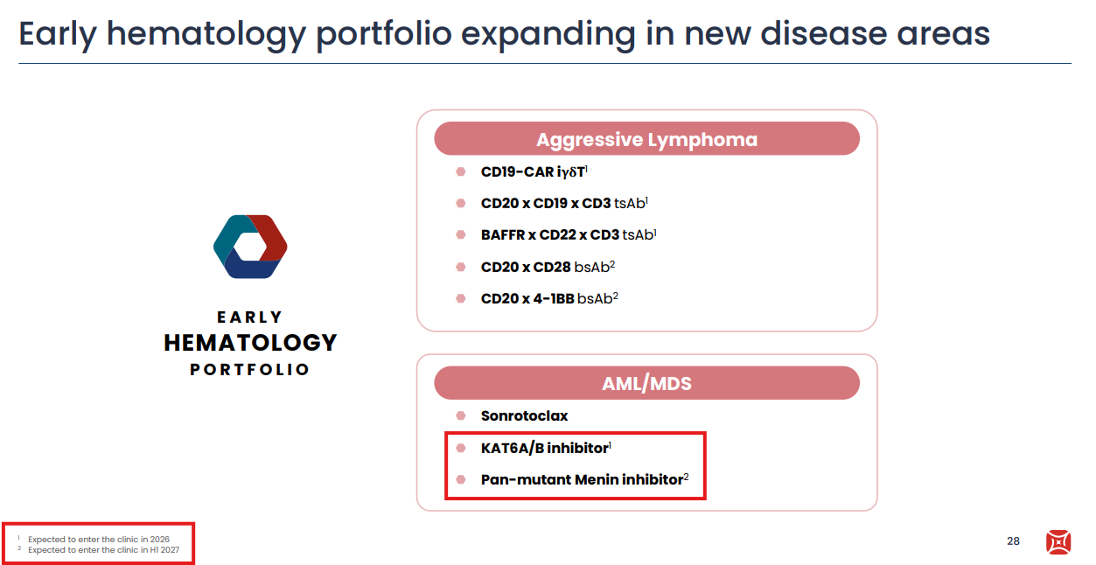

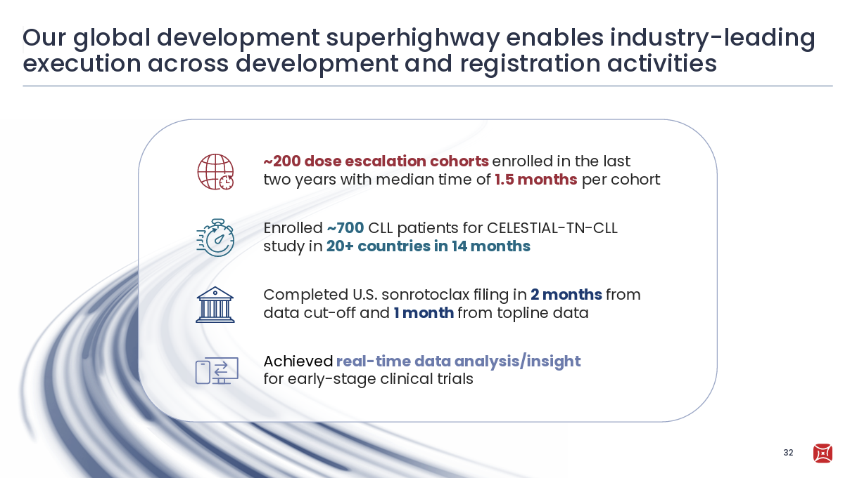

For questions, please reach out to:
International / Affiliates: Harjit Bajwa
US: Richa Sharma

Invite your colleagues to CI Edge | Manage Email Preferences | Unsubscribe

This document/email contains competitive intelligence collected via an approved competitive intelligence supplier working on behalf of AbbVie. We collect competitive intelligence consistent with industry standards and AbbVie policy. Not for field distribution. Please reach out to APEX/IMABI, Legal, or OEC teams with any questions.

